Department of Statistics

The Wharton School

University of Pennsylvania

STAT 603 August 2005

Module 5

Variance and the Volatility of Investments

Random Variables in Finance

Random variables are used in Finance to represent returns on investments.

Variance of such random variables measures the volatility (risk) of the investment.
Example
Let Red, White and Green denote three hypothetical investments with these probability distributions for their annual gross-returns

Probability | 1/6 | 1/6 | 1/6 | 1/6 | 1/6 | 1/6
Green | 0.8 | 0.9 | 1.1 | 1.1 | 1.2 | 1.4
Red | 0.06 | 0.2 | 1 | 3 | 3 | 3
White | 0.95 | 1 | 1 | 1 | 1 | 1.1
The expected values and standard deviations of the corresponding annual percentage changes are
Investment | Expected Return | StDev of Return
Green | 8.3% | 20%
Red | 71% | 132%
White | 0.8% | 4%
Which of these three investments is most appealing to you? What tradeoffs did you consider?

Remark: Green matches the long-run historical performance of the US stock market, as reflected by the value-weighted index since 1925, adjusted for inflation.

We calibrated White to approximate the historical performance of 30-day Treasury Bills, also adjusted for inflation.

Notice how closely the means and standard deivations of Green and White match those of the annual gross-returns of the Stocks and T-Bills

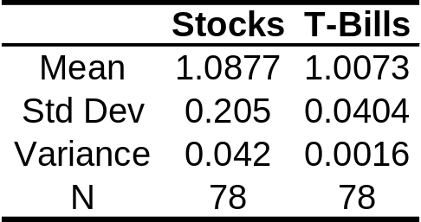

We made up Red. As you’ll see, that’s too bad!
The data for these indexes is contained in annual_markets.jmp.
The following Overlay Plot shows the performance through 2004 of these two indexes on the log scale (BBS, p.188-191)

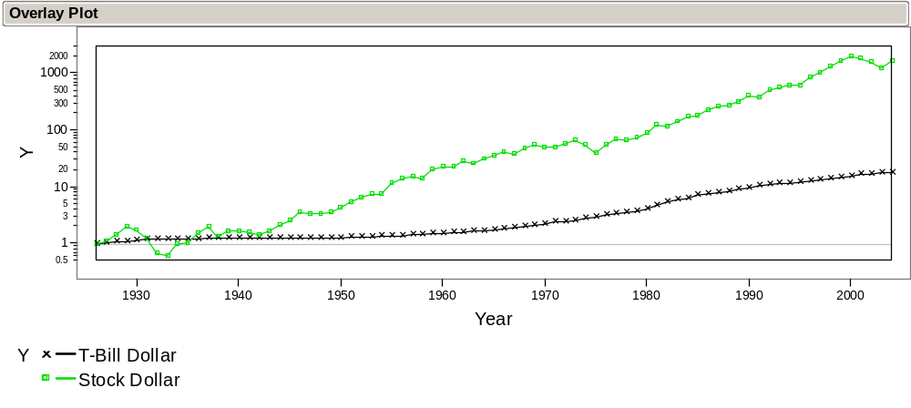
The following plot (using the same scale), shows the indexes adjusted for inflation. Note that T-bills no longer appear to be so “risk-free”.

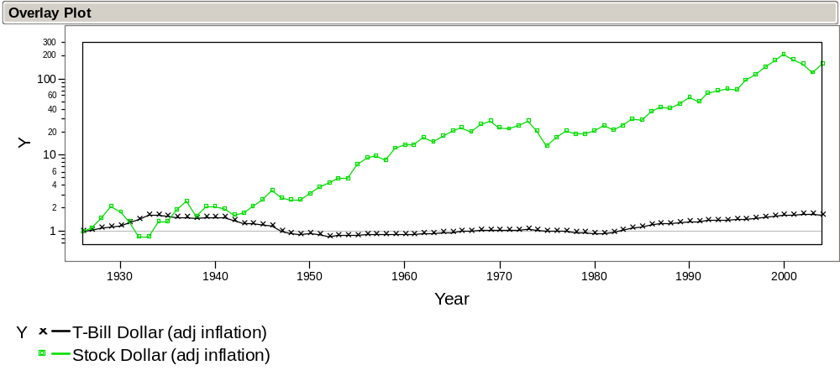
A Simulation Experiment

Suppose you begin with a $1000 investment in each of Red, White and Green

The outcome from rolling three dice determines the annual outcome of the investment of matching color

The value of the investment value changes according to the gross-return given in the appropriate column of the table.

For example, suppose that on the first roll of all three dice, you obtain

(Green 2) (Red 5) (White 3)

Then the values of the investments after the first year are

Green: $1000 · 0.9 = $900
Red: $1000 · 3 = $3000
White: $1000 · 1 = $1000
Suppose the second roll gives

(Green 4) (Red 2) (White 6)

By compounding, you get

Green: $900 · 1.1 = $990
Red: $3000 · 0.2 = $600
White: $1000 · 1.1 = $1100

Note that Green went down by 10% and then up by 10%, but ended up losing value.

Why does that happen?
A Class Experiment

Form teams of 3 to 4 students.

Start with $1000 in each investment as above and carry out the simulation for 20 years of returns. Each roll of all three dice represents one year.

Roles for team members

“Nature” rolls the dice; “Market” finds the dice and records outcome; “Accountant” keeps track of what happens; others manage and keep the rest making progress.

Record the sequence of results on the results form as shown on the next page

We’ve filled in the first two rounds to match the previous two outcomes to illustrate the calculations. Use the outcomes from rolling the dice to determine what happens to your investments.

Round | Green | Red | White
Starting value | $1000 | $1000 | $1000
gross-return₁ | 0.9 | 3 | 1
value₁ | 900 | 3000 | 1000
gross-return₂ | 1.1 | 0.2 | 1.1
value₂ | 990 | 600 | 1100
gross-return₃
value₃
gross-return₄

What happened? Are you surprised?

A Hybrid Investment

Consider a fourth investment which puts half in Red and half in White – call it Pink.

The gross-return on Pink is just the average of the gross-return in each round on Red and White. So, you can find out what happens to Pink without needing to roll the dice further.

For example, for the first round illustrated above, the gross-return on Pink is the average of the gross-return on Red and White, namely (3+1)/2 = 2.

Pink: $1000 · 2 = $2000

In the second round, the gross-return on Pink would be (0.2 + 1.1)/2 = 0.65 yielding

Pink: $2000 · 0.65 = $1300

How does Pink fare in your simulation?

No more dice tossing. Just compute the gross-returns using the information recorded on your data sheet.
Performing the Simulation on a Computer
The file dicesim.jmp is set up to perform the simulation in JMP. Opening the file and adding 20 rows yields:
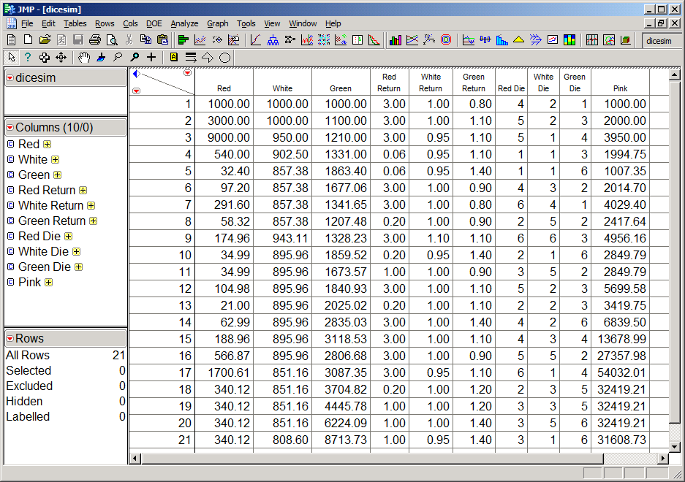
Essentially, the computer “rolls the dice” in the three columns Red Die, White Die and Green Die.

Note the persistent behavior of each of these four investments, especially if you let the computer do a few more rounds. Which investment consistently wins?

Variances and Volatility Drag

Let’s turn to understanding the simulation results

Example: Your starting salary was $100,000. You received a salary increase of 10% and then a salary reduction of 10%. What is your current salary?

What would happen to your salary if this up/down bounce was repeated over and over?

Volatility hurts by eating away at the average rate of return
As we will see below, it turns out that

Long-run gross-return ≈ Expected gross-return – Variance/2

The quantity Variance/2 is called “volatility drag”

Applied to annual returns on Red, White and Green, we obtain (with more digits shown)

Investment | Mean | StDev | Var | Mean–Var/2
Green | 1.083 | .195 | .038 | 1.064
Red | 1.710 | 1.32 | 1.755 | 0.833
White | 1.008 | .045 | .002 | 1.007

It is now clear why Red and White are both losers!

But why did Pink do so well?

Analyzing a Mixed Investment

Pink is itself a random variable with a probability distribution. Using our previous formulas, we can directly calculate

Investment | Mean | StDev | Var | Mean –Var/2
Pink | 1.359 | 0.662 | .439 | 1.140

Wow! Even though Red is a big loser and White is pretty poor, mixing the two losers yields Pink, a big winner.

What’s going on?

An Easier Way to Calculate E(Pink) and Var(Pink)

As we will see in Module 6, we can obtain E(Pink) and Var(Pink) using the formulas

E(Pink) = .5 E(Red) + .5 E(White) = 1.359

Var(Pink) = .5² Var(Red) + .5² Var(White) = .439

Note that the first formula makes perfect sense: the average of averages is itself an average.

Justification for the Volatility Drag Adjustment – if you would like to know!

Suppose our initial wealth at time 0 is W₀ and the gross-return from period t-1 to period t is R_{t}.

Our wealth at the end of year 1 is W₁ = W₀ R₁

In general, our wealth at the end of year T is

W_{T} = W_{T-1} R_{T} = …= W₀ R₁R₂ ⋅⋅⋅ R_{T}

Believe it or not, it is easier to take logs so that we can work with sums instead of products:

log W_{T} = log W₀ + log R₁+ log R₂ + ⋅⋅⋅ + log R_{T}
= log W₀ + T avg log R_{t}
≈ log W₀ + T E[log R_{t}]

As the number of time points increases, the average of log R_{t} gets closer to the expected log return. This is another name for the long-run growth rate.
Here is where the Volatility Drag enters. Calculus produces the approximation

log(1+x) ≈ x – x²/2

which works well when x is close to zero.

As long as the average gross-returns are close to 1, we obtain (using the “little r” form for writing the gross-return as R_{t} = 1 + r_{t})

E log R_{t} = E log (1+r_{t}) ≈ E (r_{t} – r_{t}²/2)
≈ E (r_{t} ) – Var(r_{t})/2
and by “unlogging” (taking the exponential) we get – hold on to your seats –
W_{T} ≈ W₀ × exp(T E[log R_{t}])
≈ W₀ × [exp(E (r_{t}) – Var(r_{t})/2)]^{T}
≈ W₀ × [E R_{t} – Var(R_{t})/2]^{T}
This approximation to the wealth W_{T} shows that the rate of growth per time period is close to the expected return minus the volatility drag.

Whew! But relax, you’ll see these ideas again in Finance.
Take-Away Review

Random variables are used to model the returns on investments in finance.

The long-term value of an investment depends upon its average rate of return and its volatility.

Volatility is another name for the variance of the return.

Variance eats away the return via the volatility drag.

Mixing investments is a means to achieving better investments with higher long-term returns.

Next Module

Portfolios and covariance: how to mix investments to reduce risk while preserving returns.

To find the value at the end of a year, multiply the value at the start of the year by the gross-return. If you start with S dollars invested and finish with F dollars, then the gross-return R is just R =F/S. We denote these gross-returns by “big R” to distinguish them from “little r” returns computed from R = 1+r . “Little r” returns become percentage changes when multiplied by 100.
To recalculate these, clicking on the Apply button in the Formula Editor Window for each die column.
OK, we agree, the second one is not so obvious. We’ll save it for Module 6..

